**WORLD ENVIRONMENT DAY-2012, DHULIKHEL, KAVRE**

As celebrated elsewhere across the globe, the World Environment Day was observed in Dhulikhel, Kavre on Tuesday, 5th June 2012. World Environment Day 2012 Kavre celebration committee formed under the co-ordination of Integrated Effort for Development Nepal (IED Nepal) and District Development Committee (DDC) Kavre organized a 3-day program focused on the environment in and around Dhulikhel. The committee include IED Nepal, DDC Kavre, District forest office Kavre, District soil conservation office Kavre,District Agriculture Office Kavre, Agriculture Development Bank Dhulikhel, Nepal Environment Tourism Initiative Foundation (NETIF),Rotary Club Of Dhulikhel, Dhulikhel Municipality, Banepa Municipality, Panauti Muncipality, Dhulikhel Jaycees, Dhulikhel Environment Tourism Initiative Foundation (DETIF), Dhulikhel Chamber Of Commerce, Community Development Relief Agency (CDRA),Community Forest Federation Kavre, Kathmandu University, Dhulikhel Hospital, Rotary Club Of Kavre Banepa.

The main message of the event was to spread awareness amongst the local people of Dhulikhel about the importance of protecting our valuable natural environment and keeping the surrounding area clean in order to promote better environment and a green economy.

To mark World Environment Day-2012, a tree planting ceremony was conducted in the periphery of Dhulikhel municipality ( road side) **during the main day celebration on 5th** **June, 2012**. Dhulikhel municipality supported Rs 25,000 for the tree plantation program. About 50 ornamental plants of fully grown (medium size) were planted. After the tree planting program, there was a rally organized through the streets of Dhulikhel spreading the message of World Environment Day and the main theme – “Green Economy : Does it include you? ( 2012 World Environment Day Theme).

The rally and following programs were attended by NETIF board members and staffs, Hoteliers, Rotary Club of Dhulikhel, Dhulikhel Chamber of Commerce and Industry, Local Schools and college students, The Chef’s Association of Nepal, Local Clubs and social groups, police members and the local community. During the parade about 75 waste bins made of bamboo baskets with metal stands were placed in streets of Dhulikhel municipality. The waste bins were provided by NETIF.

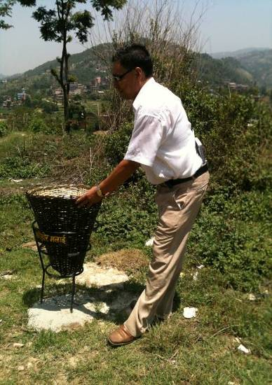

After the rally there was a talk program in Dhulikhel Municipality and the main theme was on “Green Economy”. All the honorable guests in their short speech gave a message to keep the environment clean and green.

During the day there was also a display of organic vegetables in Dhuliklhel Municipality office by Everything Organic Nepal (EON) that was both for exhibition and sale purposes in order to promote and support the growing organic vegetable industry in the local area.

**The committee also organized programs such as** Oratory Contest on Green Economy & Sustainable development; School level Art Competition on Green Economy at Bhakteshwor School, Benepa , Budol and Photo Contest on Environment online on June 3,2012 and on June 4,2012 Community tree plantation in Nayagaw ,Suwal Tole & Gosaithan and Workshop on Reducing  the  pesticides & insecticides in Agriculture at Baluwa Pachkhal were organized.

The last program for the day was Certification to the partner and winner of contest that was organized before the environment day. The day was considered a great success in Dhulikhel, Kavre. The message and importance of World Environment Day was well and truly spread throughout the region.