**g]kfn kof{j/0f tyf ko{6g hfu/0f cfwf/lznf**

**xf]d :6] cWoog e|d0f**

**@@ –@$ r}q @)^(**

**k[i7e"ld M**

g]kfn k|fs[lts ;'Gb/tf Pj+ h}ljs ljljwtfk"0f{ /fi6« xf] . oxfFsf] k|fs[lts ;Dkbf, df}lns snf Pj+ ;+f:s[lts klg ljZjs} nflu cfsif{0f s]Gb« aGb} cfPsf] 5 . oxfFsf ef}uf]lns, ;f+:s[lts, wfld{s, ;Dkbf / w/f]x/x?n] g]kfndf ko{6g If]qsf] a[xt ;+efjgfnfO{ :ki6 kf/]sf] 5 . To;}n] ko{6g If]q d'n's s} nflu Pp6f ;bfjxf/ cfly{s ;Da[l4sf] dfWod aGg ;Qm5 t/ k|f/les r/0fdf /x]sf] ko{6g If]qsf ;fd' jftfj/0fLo c;Gt'ng Pp6f u+eL/ r'gf}ltsf] ?kdf b]vfk/]sf] 5 . ko{6g If]qaf6 k|fKt ug{ ;lsg] nfenfO{ k|To]s gful/s ;dIf k'¥ofpg d'n'ssf ;Dk"0f{ ;d'bfo, gLlh If]q, ;/sf/ / u}Å ;/sf/L ;+:yfx? lhDd]jf/L k"j{s ls|oflzn x'g h?/L 5 .

ko{6g If]qsf] nfenfO{ :yflgo ;d'bfo ;Dd k'–ofpgsf] nfuL xf]d :6] Pp6f /fd|f] ljsNksf] ?kdf ljsf; eO{/x]sf] ;Gbe{df g]l6kmn] cfkm\gf] sfo{If]qdf xf]d :6] ;DjGwL cWoog sfo{, 5nkmn ;+rfng ub}{ cfPsf] 5 . :yflgo ;d'bfosf] xf]d :6] k|lt rf;f] jl9/x]sf] ;dodf g]l6kmsf] cfof]hgfdf g]kfn / Plzof s} gd"gf xf]d :6] 3n] ufpF / k|f/lEes r/0fsf] /x]sf] e'em'8= ufpF cWoog e|d0f u/fpg] sfo{ ;DkGg ePsf] 5 .

**cWoog e|d0fsf]] pB]Zo M**

**kl/of]hgfsf] d'Vo pB]Zo M**

!= cWoog e|d0fn] xf]d :6] ;+rfng ljwL yfxf kfpg d4t k'Ug] 5 .

@ xf]d :6] ubf{ o;sf] kmfO{bf, ;d:of / r'gf}ltsf] jf/]df xf]d :6] ;+rfns ;+usf] 5nkmnjf6 hfgsf/L k|fKt ug{ ;Sg]5g\ .

#= xf]d :6] ;+rfnsx?sf] Ifdtf / s[oflzntf b]v]/ cfTdljZjf; j9g] 5 .

$= xf]d :6] cfkm\gf} 3/ ufpF kl/j]zdf ;+rfng ug{ ;lsg] jf/]df hfgsf/L k|fKt ug{ ;Sg]5g\ .

%= xf]d :6]n] j}sNkLs /f]huf/Lsf] ;[hgf ul/ lhjg:t/ ;'wf/ ug{ ;lsg] jf/]df yfxf kfpg ;Sg] 5g\ .

^= sf7df08f} b]lv b'/b/fh If]qdf :yflgo cfdfx?n] xf]d :6] ;+rfng u/]sf] b]v]/ zx/ b]lv glhsdf /x]sf ufpFdf xf]d :6] ;+rfng ug{sf] nfuL ;fd'lxs ?kdf nfUg] k|]/0ff k|fKt ug]{5g\ .

&= ;fgf xf]6n nhnfO{ xf]d :6]sf] ?kdf ;+rfng ug{, Joj;fodf gnfu]sfnfO{ cfkm\gf] 3/df xf]d:6] ;+rfng ug{ / xf]6n Joj;fodf nfu]sfx? cfkm\gf] jl/k/L xf]d :6] k|j4{g ug{ ;xof]uL x'gsf] nfuL e|d0f ;xof]uL x'g]5 .

**cWoog e|d0fsf ;xefuLx? M**

-s_ lr;fkfgL, g'jfsf]6 lhNnf– # hgf

-v_ d'nvs{, cf]v|]gL, sf7df08f} lhNnf – ( hgf

-u_ gu/sf]6, eQmk'/ lhNnf – !%

-3_ g]l6km s]Gb|Lo sfof{no – # hgf

**cWoog e|d0f u/]sf] :yfg M**

!= ndh'8= lhNnfsf] 3n] ufpF / e'em'8= ufpF

**cWoog e|d0fdf b]lvPsf ljifox? M**

**3n] ufpF M**

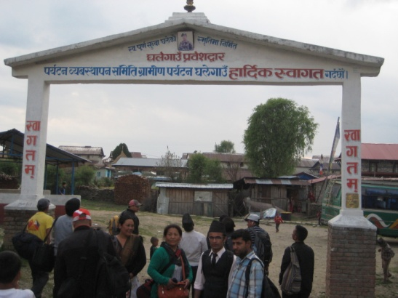 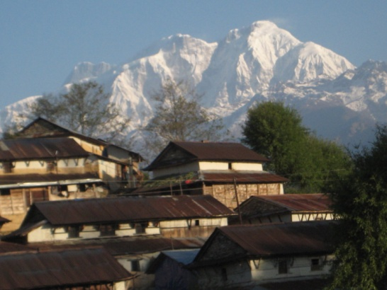

**3n] ufpFsf] k|j]z 4f/ ljxfgL kv 3n] ufpF / lxdfnsf] b[Zo**

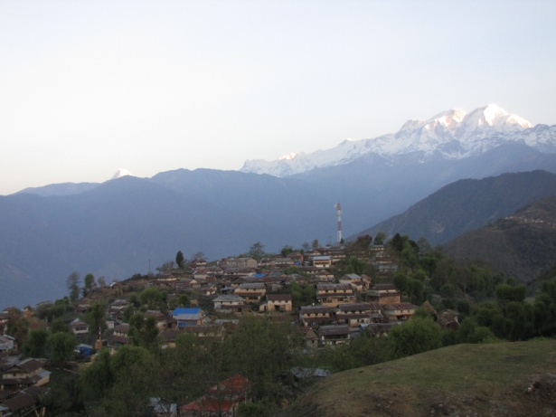 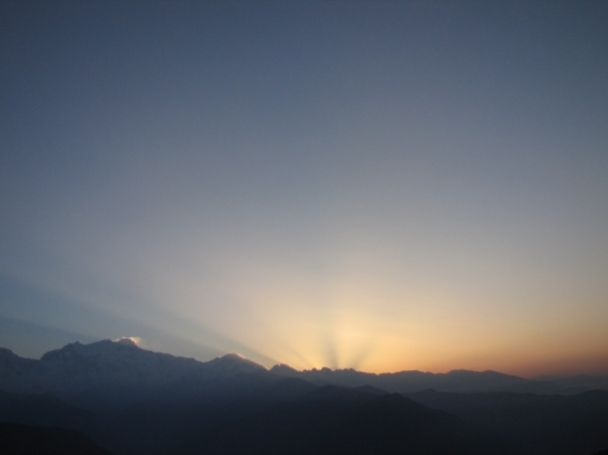

**3n] ufpsf] b[Zo 3n] ufpF jf6 b]lvg] ;"of]{bo**

!= 3n] ufpFsf] @^ 3/df xf]d :6] ;+rfng eO{/x]sf] .

@= ;ldlt 4f/f ;+rflnt ePsf], ;ldltn] g} k|To]s 3/df kx'gf tf]Sg] Joj:yf u/]sf], kfn}kfnf] kx'gf /fVg] Joj:yf ePsf],

#= k|To]s xf]d :6]df ;ldltn] :yflgo vfgfsf] d]g' Joj:yf u/]sf]

$= xf]d :6] ;+rflnt 3/df kx'gfsf] nfuL cnUu} sf]7fsf] Joj:yf u/]sf] .

%= sf]7fsf] ;hfj6, vf6, j]8df Ps ?ktf u/]sf].

^= d]g'df Joj:yf u/] cg';f/ :yflgo vfgfsf] b/df Ps ?ktf ePsf] .

&= sf]7f, 3/ cfug, jf6f]3f6f]sf] kmf]x/ Joj:yfkg /fd|f] u/]sf] .

*= ;j} 3/df zf}rfnosf] Joj:yf ePsf] .

(= vfg]kfgL, wf/fsf] Joj:yf ePsf] .

!)= kz'k+IfL kfn]sf] 3/df plrt Joj:yfkg u/]sf] . hyfefjL kz' 5f]8g], kmf]x/ jgfpg] sfo{ gePsf] .

!!= hldgsf] ;+/If0fsf] nfuL 9'+ufsf] plrt k|of]u ul/Psf], jf6f]3f6f] 3/ cfugdf clwstd 9'+uf k|of]u ePsf] .

!@= kx'gfx?sf] dfu ePdf ;f:s[lts sfo{qmd ;+rfng ug]{ Joj:yf /x]sf] .

!#= jftfj/0fLo b[li6sf]0fn] vf]nf, h+un, kxf8, lxdfnL >[vnf b]lvg] :yfgsf] ?kdf kl/ro jgfPsf] .

!$= OGwgsf] ?kdf bfp/f clwstd k|of]]u x'g] ePsf]n] bfp/f ;+sngsf] ljwL / dfqf dgdf]xs ePklg jgljgfz eO{/x]sf] .

!%= u'?8= ;f:s[lt ;+u|xfno cjnf]sg

!^= lrof jufg / cuf{lgs lrofsf] :jfb .

!&= u'Djf, lxdfnsf] b[Zo, u'?8= ;:s[lt e]ife'iff rfnrng, ufpFn] lhjg .

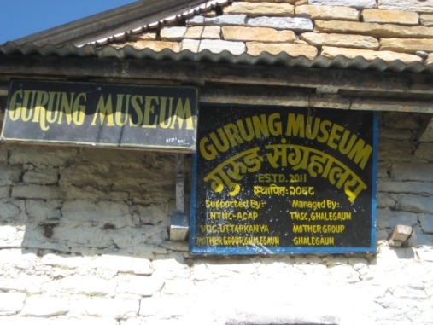 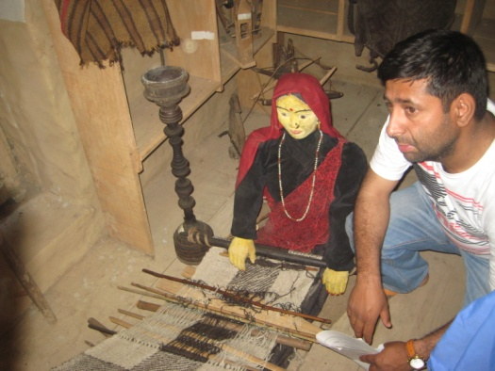

u'?8= ;+u|xfno ;+u|xfnosf] leq ;xefuL kmf]6f] lvrfpb}

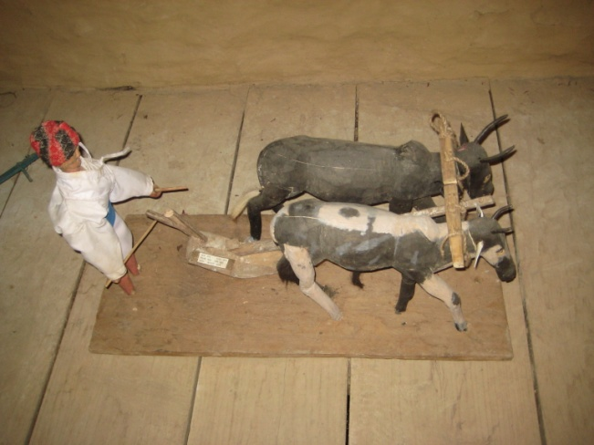

;+u|xfnosf] leqL b[Zo

**e'em'8= ufp M**

 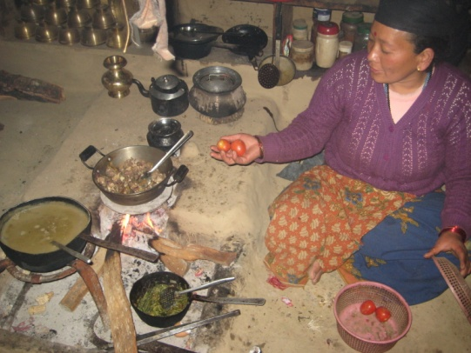

**e'em'8= ufpFsf] k|j]z 4f/ e'em'8= ufpFsf] xf]d :6]df 3/j]6L vfgf ksfpb}**

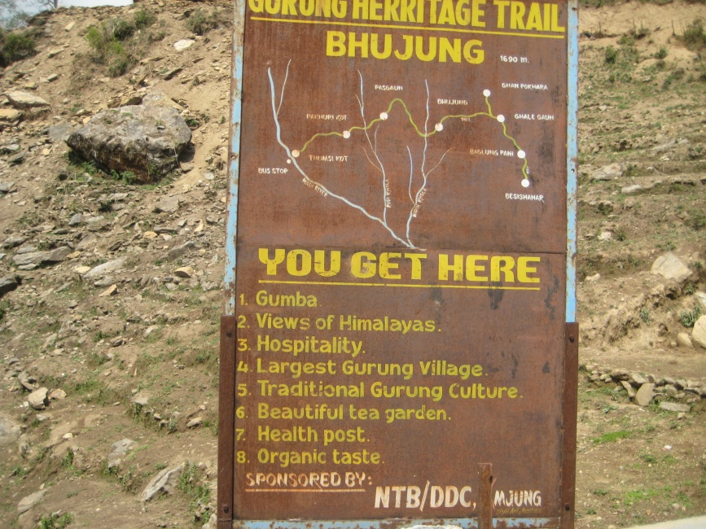

**e'h'8=df kfx'gfx?n] kfpg] ;]jf**

!= e'em'8= ufpF ljsf; ;ldltdf Ps} 7fpdf $)) 3/, jf6f]3f6f] dgdf]xs /x]sf] .

@= ;ldlt 4f/f ;+rflnt ePsf], ;ldltn] g} k|To]s 3/df kx'gf tf]Sg] Joj:yf u/]sf], kfn}kfnf] kx'gf /fVg] Joj:yf ePsf] .

#= xf]d :6] ;+rfng / Joj:yfkg 3n] ufpFsf] bfhf]df Jojl:yt geO{;s]sf] .

$= xf]d :6] ;+rflnt ;j} 3/df kx'gfsf] nfuL cnUu} cfjZos sf]7fsf] Joj:yfkgdf sld /x]sf] .

%= sf]7fsf] ;hfj6, vf6, j]8df Ps ?ktf gcfO{;s]sf] .

^= ;Nnfxf cg';f/ vfgfsf] b/df Ps ?ktf sfod ug]{ sf]lz; u/]sf] .

&= sf]7f, 3/ cfug, jf6f]3f6f]sf] kmf]x/ Joj:yfkg /fd|f] u/]sf] .

*= ;j} 3/df zf}rfnosf] Joj:yf ePsf] .

(= vfg]kfgL, wf/fsf] Joj:yf ePsf] .

!)= kz'k+IfL kfn]sf] 3/df plrt Joj:yfkg u/]sf] . hyfefjL kz' 5f]8g], kmf]x/ jgfpg] sfo{ gePsf] .

!!= hldgsf] ;+/If0fsf] nfuL 9'+ufsf] plrt k|of]u ul/Psf], jf6f]3f6f] 3/ cfugdf clwstd 9'+uf k|of]u ePsf] .

!@= xlg xG6L8= ug]{ ufpFsf] ?kdf kl/ro jgfPsf], k|To]s jif{ # j8fsf] b/n] kfn} ;+u df}/Lsf] dx sf6g] k|rng /x]sf], sf6]/ Nofpg] j8fn] $)) 3/nfO{ g} dx pknJw u/fpg] lgod /x]sf] .

!#= j];L / vf]nfjf6 s[lif pTkfbg / jfn'jf /f]kj] -ljB't jf6 rNg]_ jf6 ufp ;Dd Nofpgsf] nfuL $)) 3/sf] nfuL # j6f /f]kj] lgdf{0f / ;+rfng ePsf] .

!$= cGgk"0f{ sgh/e];g sfo{qmdsf] sfof{no /x]sf], :yflgo ;d'bfonfO{ xf]d :6] / cGo ljsf;sf ultljwL ;+rfng u/]sf] .

!%= kx'gfx?sf] dfu ePdf ;f:s[lts sfo{qmd ;+rfng ug]{ Joj:yf /x]sf] .

!^= OGwgsf] ?kdf bfp/f clwstd k|of]]u x'g] ePsf]n] bfp/f ;+sngsf] ljwL / dfqf dgdf]xs ePklg jgljgfz eO{/x]sf] .

!^= lrof jufg / cuf{lgs lrofsf] :jfb .

!&= lxdfnsf] b[Zo, u'?8= ;:s[lt e]ife'iff rfnrng, ufpFn] lhjg .

**l;sfO{ M**

!= xf]d :6] ug{ rfxg] ;xefuLx?df cfTdljZjf;df j[l4 ePsf] .

@= xf]d :6]sf] nfuL w]/} nfut, 7'nf] Joj:yfkg, emGeml6nf] k|s[of g/x]sf] jf/]df hfgsf/L k|fKt ePsf] .

#= xf]d :6] Joj:yfkgsf] nfuL rflxg] cfwf/e"t lglt lgod, Joj:yfkgsf] jf/]df yfxf kfPsf] .

$= xf]d :6] 3/ dfq geP/ 3/sf] jflx/L jftfj/0fdf ;d]t ;kmf ;'U3/nfO{ ljz]if Wofg lbg'kg]{ .

%= xf]d :6] Pshgfn] z'? ug{ ;lsG5 t/ ;ldlt u7g ul/ ubf{ Joj:yfkgdf d4t k'Ug], jfXo ;xof]u k|fKt ug{ cfwf/ / ;fd'lxs kxn x'g],

^= xf]d :6]n] :yflgo /f]huf/L ;[hgf u/]sf] h:t}, ufO{8, k+IfL tyf kz'kfng, t/sf/L v]lt, :yflgo x:tsnf, :yflgo vfB kbfy{ cflbsf] ljqmL eO{ cfocfh{g ug{ d4t k'Ug] .

**&= xf]d :6] ;+rfng ul/Psf] :yfgdf ufO{8 Joj:yf ePsf] v08df kx'gfx?nfO{ ljleGg :yfg e|d0f u/fpg] / kx'gfx?n] /dfO{nf] ul/ ;do Joltt ug{ kfpg] 5g\ . 3n] ufpdf ;ldltsf ;lrj ufO{8sf] ?kdf ;xof]uL /x] eg] e'em'8= ufpFdf klg ufO{8sf] Joj:yf gx'bf 3n] ufpFsf ;lrjn] ;3fPsf lyP .**

**\*= kx'gfx?nfO{ ljleGg ultljwLdf ;+dnUg u/fpg] jftfj/0f jgfpg h?/L 5 h:t} M jf/L vGg], jfv|f r/fpg hfg], kw]/f hfg], 3/ leqsf] sfd ug{ k|]l/t ug]{ h:tf kb{5g\ . o; ls;Ldsf ultljwL ePdf kx'gfx?sf] j;fO{ /dfO{nf] x'g'sf] ;fy} nDjLg hfG5 h;n] ubf{ xf]d :6]sf] cfDbfgL j9g hfG5 .**

**(= e'h'8= ufpFdf xf]d :6] ;+rfng ug]{ 3/n] Joj:yfkgsf] cfwf/e't hfgsf/L yfxf gx'bf kx'gfx?nfO{ cgfjZos emGem6 Joxf]g'{ k/]sf] .**

**r'gf}lt M**

!= xf]d :6] ;fd'lxs >djf6 pTkfbg x'g] Joj;fo xf], ;fd'lxs xf]d :6] ;+rfngsf] nfuL ;d'bfodf Ps ?ktfsf] cefj x'g] .

@= xf]d :6] ;+rfngsf] cfwf/e"t ef}lts k"jf{wf/ lgdf{0fsf] nfuL cfly{s cefj x'g hfg] ;+efjgf b]lvPsf] o;sf] ;dfwfgsf] nfuL s'g}klg lgsfo ;xof]usf] nfuL tof/ gePsf] cj:yf .

#= xf]d:6] / :yflgo xf]6n Joj;fo ;+u tfnd]n gldNbf xf]d :6] / xf]6n Joj;fo ljr cgfjZos c;dembf/L j9g uO{ xf]d :6]sf] jhf/Ls/0fdf gsf/fTds k|efj kg{ hfg] .

**;+efljt pknJwL M**

!= ;fgf xf]6n nh ;+rfng ul//x]sfx? JolQmut kxndf ePklg xf]d :6]sf] lbzfdf hfg ;Sg] .

@= ko{6g Joj;fodf ;+dnUg gePsfx?n] cfkm\gf] 3/ ufpdf xf]d :6]sf] jf/d]f rrf{ ug{ ;Sg] JolQmut kxn ug{ ;Sg] .

#= o'jfx? ;ldlt lgdf{0f ul/ JolQmut kmfO{bf ;fd'lxs k|ltj4tfsf] cfwf/df xf]d :6] ;+rfng ug{ ;Sg] ;+efjgf /x]sf] .

$= xf]d :6] s] xf], s;/L ;+rfng x'bf] /x]5, ;+rfng ubf{ s] s] s'/fdf Wofg lbg'k5{ h:tf cfwf/e"t 1fg :ynut cWoog, 5nkmn / k|ToIf cg"e"lt 4f/f 1fg k|fKt ug]{ cj;/ kfPsf] x'bf xf]d :6] ;+rfng ug{ rfxfg]nfO{ 7'nf] d4t k'u]sf] .